
ACHARIYA ARTS AND SCIENCE COLLEGE
(Affiliated to Pondicherry University)
Recognized by UGC under section 2(f) of UGC act 1956
Achariyapuram, Villianur, Puducherry - 605110. Ph: 0413 – 2660731

ACTIVITY REPORT

Department | Department of Computer Applications | Event Date and Time | 21.11.2025 & 10AM
Title of the Program/Event | Artificial Intelligence and Its Applications | No of Participants (Count) | 55
Category of the event (fundamentals of AI, its practical use cases, and emerging innovations shaping the future automation, intelligent systems, and data-driven decision-making machine learning, deep learning, natural language processing, and real-world AI solutions | SEMINAR | Name of the Chief Guest , Designation, Organization details etc | Dr. J. Uthayakumar Research Head at Genesys Research and AI Labs (GRAIL)
Event Organizer | Mr.P.Vakiswaran | No of days of the event | 1
Details of the Audience (Ex: Class/ Program/ External participants) | I BCA  II BCA  III BCA | Associated External Agency (if any) | Nill
Objective of the event(4 Points) | - To explore recent advancements in data science technologies such as AI, ML, Big Data, and Cloud Computing.  - To understand the practical applications of emerging tools and techniques in solving real-world problems across various industries.  - To enhance analytical and technical skills for handling large datasets, automation, and intelligent decision-making.  - To promote awareness of ethical practices and responsible use of data-driven technologies for sustainable development. | Venue – Offline  Online – Link | AASC CONFERENCE HALL

One Page Report
REPORT ON “ARTIFICIAL INTELLIGENCE AND ITS APPLICATIONS”
With immense pleasure and academic enthusiasm, the Department of Computer Applications of Achariya Arts and Science College organized a Seminar on “Artificial Intelligence and Its Applications” on 21st November 2025 at 10:00 AM in the Conference Hall.
The session was graced by Dr.R. Ushadevi, Principal of Achariya Arts and Science College, and convened by Mr.I. Sherif Baig, Assistant Professor and Head, Department of Computer Applications. Mr. P. Vakiswaran, Assistant Professor, Department of BCA, coordinated the event.
The resource person, Dr. J. Uthayakumar Research Head at Genesys Research and AI Labs (GRAIL), delivered an insightful talk on the current trends and AI technologies in the field of AI. She explained various concepts such as Artificial Intelligence, Machine Learning, Big Data, and their real-world applications.
This SEMINAR aimed to provide students with valuable insights into the rapidly evolving field of AI. The speaker elaborated on recent trends, tools, and technologies such as Artificial Intelligence, Machine Learning, and Big Data Analytics, emphasizing their real-world applications across various industries.
The session focused on:
- Exploring the significance of data-driven decision-making in modern technology.
- Introducing emerging technologies and frameworks used in data analytics.
- Motivating students to pursue research and careers in Artificial Intelligence and Its Applications.
The Seminar was highly interactive and informative, giving students a clear understanding of current industry trends and future opportunities in the field. The event concluded with a vote of thanks by the organizing team, expressing gratitude to the guest speaker, faculty members, and students for their enthusiastic participation.
The interactive session was highly informative and provided students with valuable knowledge about the scope and career opportunities in AI . The event concluded with a vote of thanks, expressing gratitude to the speaker, faculty members, and participants for making the program successful.

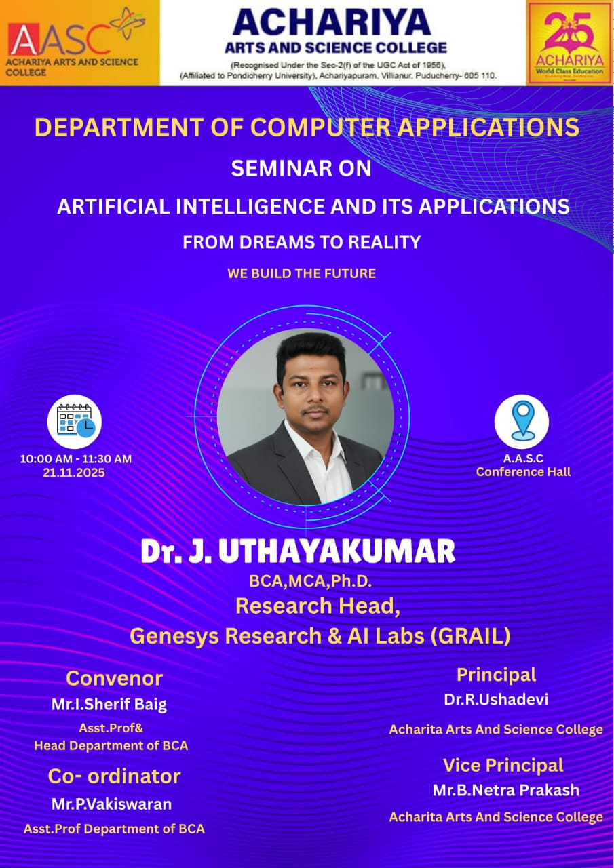 | 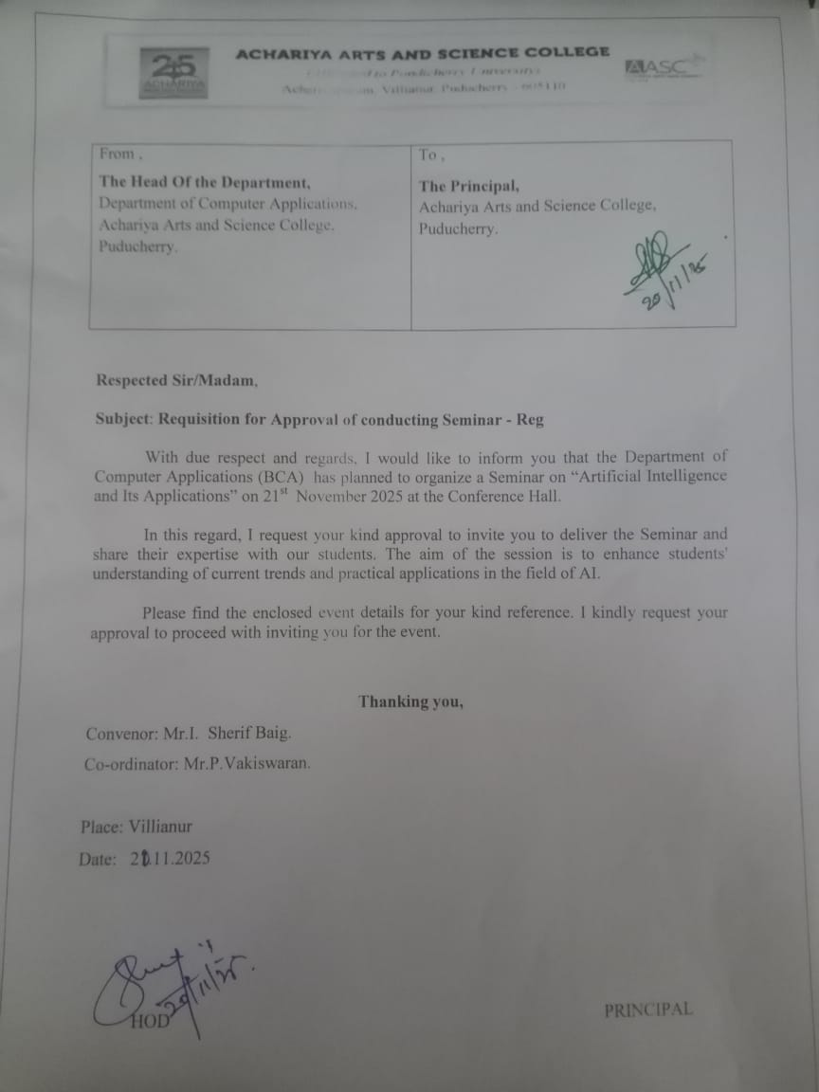
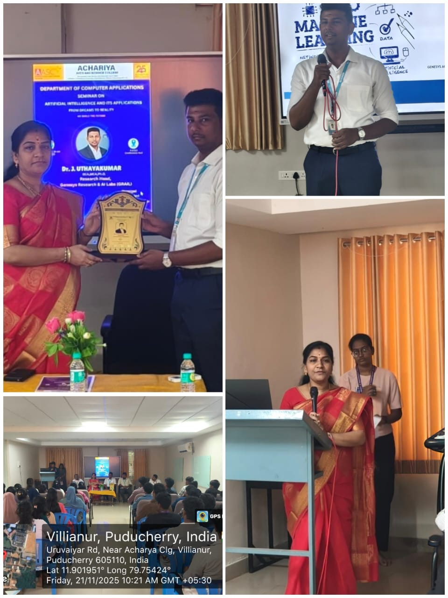 | 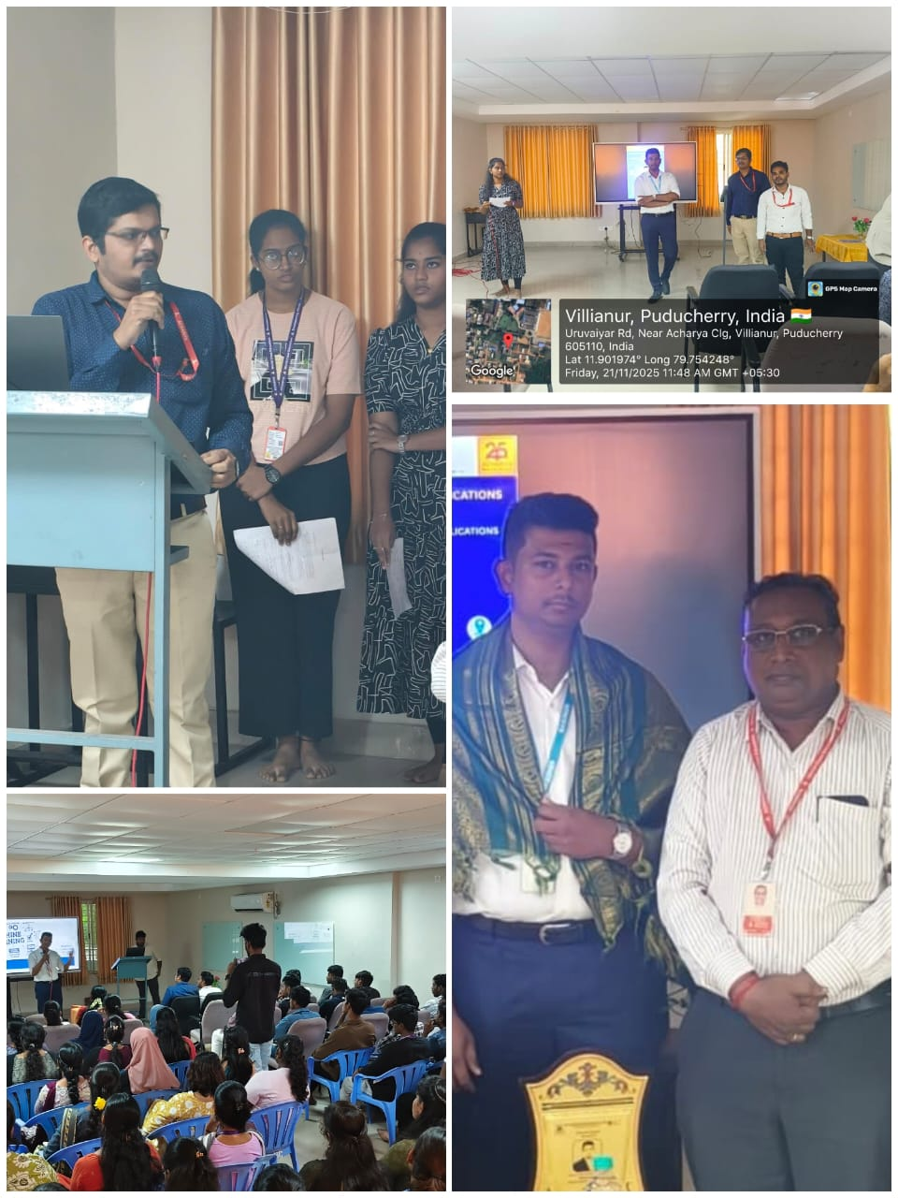

PARTICIPANTS LIST

Department | Department of Computer Applications | Event Date and Time | 21.11.2025 & 10AM
Title of the Program/Event | Artificial Intelligence and Its Applications | No of Participants (Count) | 55
S NO | REG NO | NAME | CLASS/ PROGRAMME
1 |  |  | III BCA
2
3
4
5
6
7
8
9
10
11
12
13
14
15
16
17 |  |  | II BCA
18
19
20
21
22
23
24
25
26
27
28
29
30
31
32
33
34
35
36
37
38
39
40 |  |  | I BCA
41
42
43
44
45
46
47
48
49
50
51
52
53
54
55

ORGANIZER HOD PRINCIPAL

